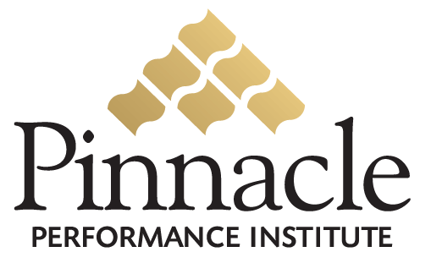


Close the Gap
between
Vision & Execution

Expose Reality…
and Act Upon It

Guarantee

Your Success!



Certify Your Team!

Are they trained and certified on regulatory requirements?

Are they equipped to excel at their responsibilities?
Are they qualified to represent the company?

Total Performance Solution
Measure your Strengths and Weaknesses
Build Confidence and Competence
Collaborate with your Support Team
Be Accountable for your Success

Assessments and Certifications
Thousands of Multimedia Video Training courses
Online Conference Rooms & Discussion Boards
Electronic Suggestions & Surveys
Goal Management System
Member Support System
Training Buddy

